# File Handling through C++ Classes

In C++, files are mainly dealt by using three classes fstream, ifstream, ofstream available in fstream headerfile.  
ofstream: Stream class to write on files  
ifstream: Stream class to read from files  
fstream: Stream class to both read and write from/to files.

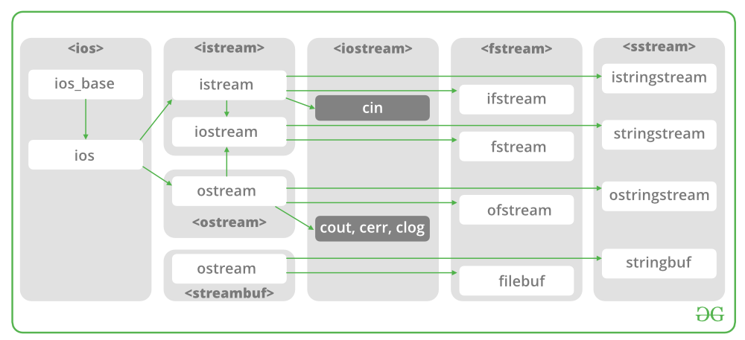

Now the first step to open the particular file for read or write operation. We can open file by  
1. passing file name in constructor at the time of object creation   
2. using the open method

For e.g.

Open File by using constructor  
ifstream (const char* filename, ios_base::openmode mode = ios_base::in);  
ifstream fin(filename, openmode) by default openmode = ios::in  
ifstream fin(“filename”);

Open File by using open method  
Calling of default constructor  
ifstream fin;  
fin.open(filename, openmode)  
fin.open(“filename”);

Modes :

| Member Constant | Stands For | Access |
| --- | --- | --- |
| in * | input | File open for reading: the internal stream buffer supports input operations. |
| out | output | File open for writing: the internal stream buffer supports output operations. |
| binary | binary | Operations are performed in binary mode rather than text. |
| ate | at end | The output position starts at the end of the file. |
| app | append | All output operations happen at the end of the file, appending to its existing contents. |
| trunc | truncate | Any contents that existed in the file before it is open are discarded. |

Default Open Modes :

|  |  |
| --- | --- |
| ifstream | ios::in |
| ofstream | ios::out |
| fstream | ios::in | ios::out |

Problem Statement : To read and write a File in C++.  
Examples:

Input :

Welcome in GeeksforGeeks. Best way to learn things.

-1

Output :

Welcome in GeeksforGeeks. Best way to learn things.

Recommended: Please try your approach on ***IDE*** first, before moving on to the solution.

Below is the implementation by using ifstream & ofstream classes.

|  |
| --- |
| /* File Handling with C++ using ifstream & ofstream class object*/  /* To write the Content in File*/  /* Then to read the content of file*/  #include <iostream>    /* fstream header file for ifstream, ofstream,    fstream classes */  #include <fstream>    using namespace std;    // Driver Code  int main()  {      // Creation of ofstream class object      ofstream fout;        string line;        // by default ios::out mode, automatically deletes      // the content of file. To append the content, open in ios:app      // fout.open("sample.txt", ios::app)      fout.open("sample.txt");        // Execute a loop If file successfully opened      while (fout) {            // Read a Line from standard input          getline(cin, line);            // Press -1 to exit          if (line == "-1")              break;            // Write line in file          fout << line << endl;      }        // Close the File      fout.close();        // Creation of ifstream class object to read the file      ifstream fin;        // by default open mode = ios::in mode      fin.open("sample.txt");        // Execute a loop until EOF (End of File)      while (fin) {            // Read a Line from File          getline(fin, line);            // Print line in Console          cout << line << endl;      }        // Close the file      fin.close();        return 0;  } |

Below is the implementation by using fstream class.

|  |
| --- |
| /* File Handling with C++ using fstream class object */  /* To write the Content in File */  /* Then to read the content of file*/  #include <iostream>    /* fstream header file for ifstream, ofstream,     fstream classes */  #include <fstream>    using namespace std;    // Driver Code  int main()  {      // Creation of fstream class object      fstream fio;        string line;        // by default openmode = ios::in|ios::out mode      // Automatically overwrites the content of file, To append      // the content, open in ios:app      // fio.open("sample.txt", ios::in|ios::out|ios::app)      // ios::trunc mode delete all content before open      fio.open("sample.txt", ios::trunc | ios::out | ios::in);        // Execute a loop If file successfully Opened      while (fio) {            // Read a Line from standard input          getline(cin, line);            // Press -1 to exit          if (line == "-1")              break;            // Write line in file          fio << line << endl;      }        // Execute a loop until EOF (End of File)      // point read pointer at beginning of file      fio.seekg(0, ios::beg);        while (fio) {            // Read a Line from File          getline(fio, line);            // Print line in Console          cout << line << endl;      }        // Close the file      fio.close();        return 0;  } |